Mokena Crossings, 9980 & 9990 190th St., Mokena, IL 60448
February 13, 2019
3 Year Lease, Negotiable
Based on Rentable Square feet below, 3-1/2% increases per year

Suite # | Square Feet | Gross Rental Rate | Gross Monthly Rental Amount | Sale Price
9980C | 2,000 SF | $17.90/SF | $2,983.33/month | $334,000 ($167/SF)

Please note survey may be different than sf shown above. Prices are subject to change without notice. Approximate Parking Ration is 5/1,000 SF.

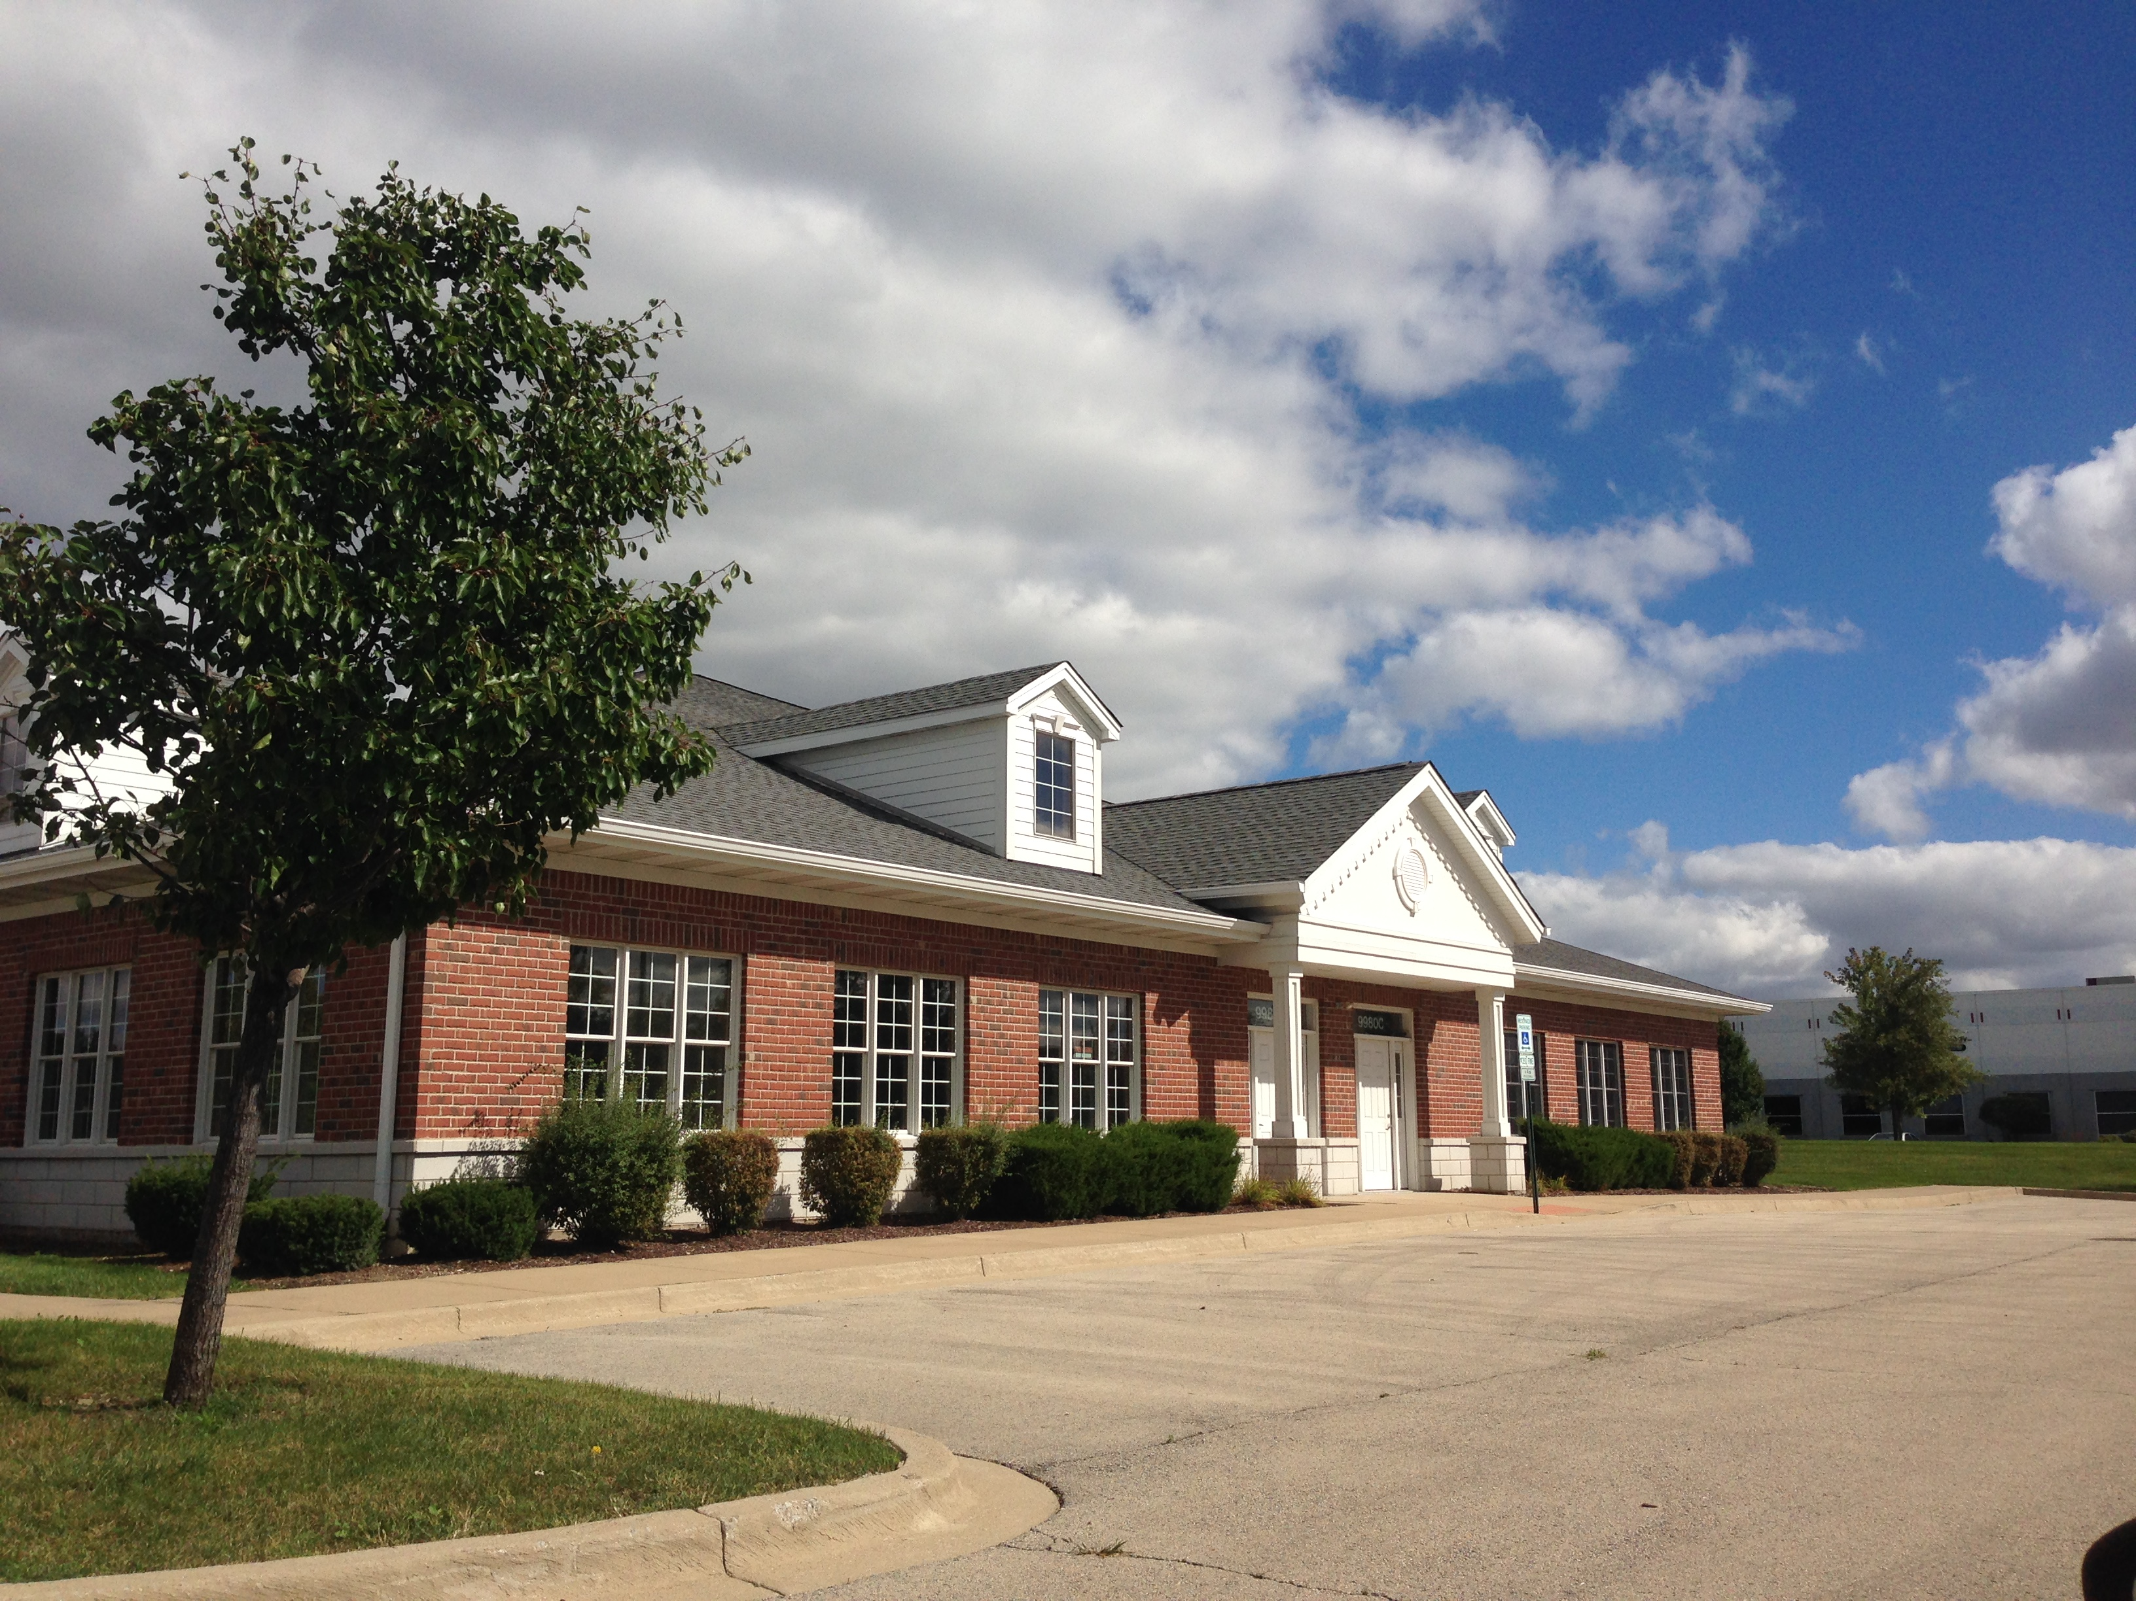

/tmp/lo/0000.doc

